Regulations:
A18

H.T No

Sreenidhi Institute of Science and Technology
(An Autonomous Institution)
Code No: 7BC02 Date: 29-Jan-2020 (FN)

B.Tech I-Year II-Semester External Examination, Jan/Feb-2020 (Supplementary)
ENGINEERING GRAPHICS AND DESIGN (CIVIL, CSE, IT and ECM)

Time: 3 Hours Max.Marks:70

Note: a) No additional answer sheets will be provided.
b) All sub-parts of a question must be answered at one place only, otherwise it will not be valued.
c) Missing data can be assumed suitably.

Part - A Max.Marks:20

Answer all QUESTIONS.

1. | Define eccentricity. Mention eccentric values for different conic sections? | [2M]
2. | Differentiate between epicycloid and hypocycloid. | [2M]
3. | What is the difference between first and third angle projection | [2M]
4. | Difference between cone and cylinder. | [2M]
5. | What is meant by development of a surface. | [2M]
6. | Draw the Front View of the figure given below.(all dimensions are in cm)  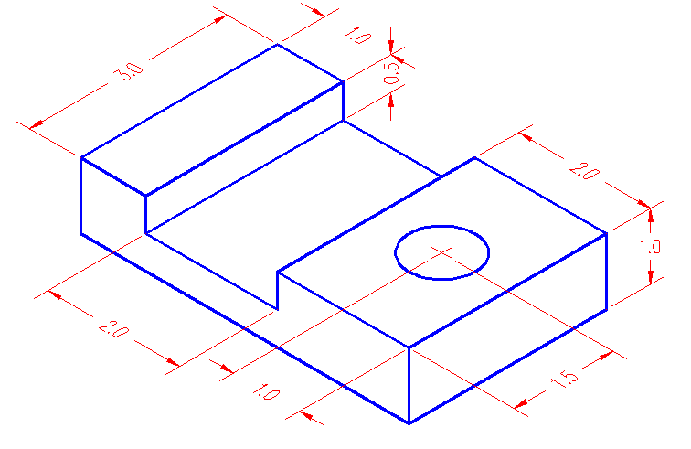 | [2M]
7. | Explain the terms trim, chamfer and fillet. | [2M]
8. | What is the difference between the isometric view and isometric projection? | [2M]
9. | Write some Boolean operations in CAD? | [2M]
10. | Define the term, polyhedron. | [2M]

Part – B Max.Marks:50
ANSWER ANY FIVE QUESTIONS. EACH QUESTION CARRIES 10 MARKS.

11. |  | Construct a conical curve when the distance of focus from the directrix is equal to 70 mm and eccentricity is 4/3. Name the curve. Also draw a normal and tangent to the curve at a point on it 25 mm from the directrix. | [10M]
12. |  | The top view of a 75 mm long line AB measures 65 mm, while the length of its front view is 50 mm. It’s one end A is in the HP and 12 mm in front of the VP. Draw the projections of AB and determine its inclinations with the HP and the VP. | [10M]
13. |  | A hexagonal pyramid, base 35 mm side and axis 70 mm long has an edge of the base parallel to the H.P. and inclined at 30⁰ to the V.P. Its axis makes an angle of 60⁰ with the H.P. Draw its projections. | [10M]
14. |  | A triangular pyramid of base side 50 mm and height 60 mm rests on H.P. on its base with a base edge perpendicular to V.P. A cutting plane parallel to H.P. and perpendicular to V.P. cuts it meeting the axis 30 mm above the base. Draw the section plan and true shape of the section. | [10M]
15. |  | Pictorial view of an object is shown in Figure. Draw the following views.  (i) Front view (ii) Top view (iii) Side view  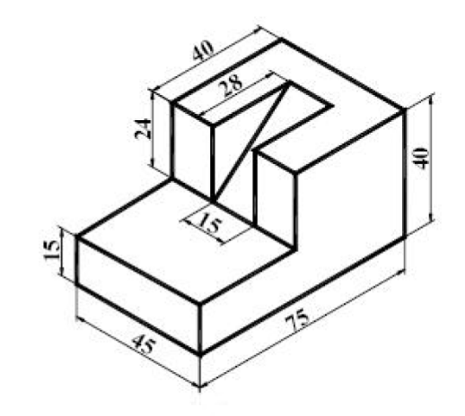 | [10M]
16. | a) | What are various software’s used in CAD. | [10M]
 | b) | Explain the various advantages and disadvantages of CAD.
17. |  | Draw the projections of a circle of 50 mm diameter resting in the HP on a point A on its circumference, its plane inclined at 45⁰ to HP and the diameter makes 30⁰ with VP. | [10M]
18. |  | A pentagonal prism of base edge 35 mm and axis 70mm lies with base on HP and axis vertical. Draw its isometric projection | [10M]

-- 00 -- 00 –

